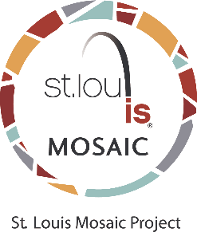

True Manufacturing Ambassador Company Actions

- Post select jobs on websites of St. Louis Mosaic Project and its partners.
- Provide Diversity and Inclusion training for employees.
- Have Employee Resource Groups for diverse associate groups.
- Partner with the International Institute and other ethnic groups or Sister Cities Organizations to get message to broader consumer base.

# # #

