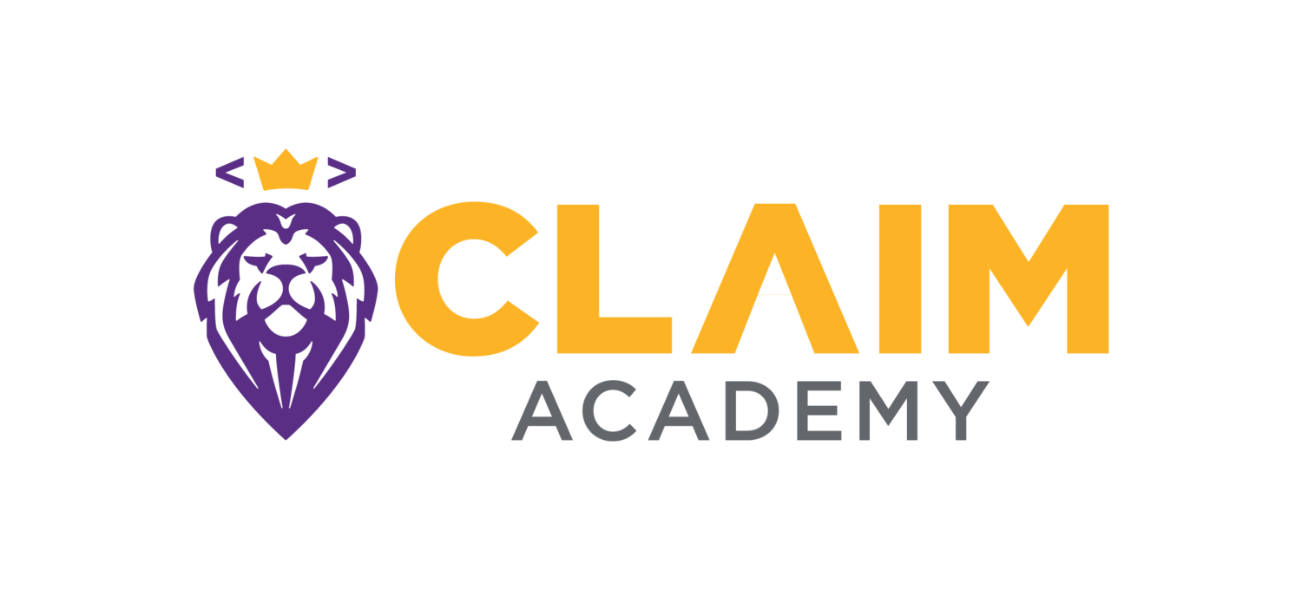

Position: Sales Development Representative
Claim Academy is helping students change their lives through a new career in technology. We are looking for individuals who have a burning desire to make a difference and be instrumental in changing people's lives. Do you have a passion for people? Are you willing to go above and beyond to help someone become successful and change the course of their life? Are you up for a challenging fulfilling career? If you answered YES then we want you to join our team as a change maker to continue our mission by reaching more people and to truly transform their life into a rewarding career.
Claim Academy is a Software Developer school seeking a Sales Rep to join our growing Student Recruitment team! As a Sales Rep on our team, you’re responsible for recruiting top-tier candidates to maximize our cohort enrollment. You’ll work with prospective students through the application & admissions process, from inquiry to acceptance, overseeing the entire admissions process for your prospects. You’ll be the primary contact and the welcoming face of the school to our prospective students as they navigate our admissions process and get to know more about Claim Academy.
At Claim Academy we provide cutting edge, skill based education that meets the needs of technology employers from countless industries. We craft our classes with care, looking for students who share our values of mutual respect, open and honest communication and personal accountability. We select a small group of highly motivated and passionate students for each class from among hundreds of applicants. You will be responsible for building each class, seeking out our values in prospective students and crafting groups of people that will accomplish amazing things together. In this position, you will have the opportunity to contribute meaningfully to the rapid growth of our organization
As an Inside Sales Representative - Student Admissions Recruiter you will:
- Be the hunter - You will find, receive and follow-up on calls, leads, and student applications by phone, email, text message and other communication mediums.
- Rely primarily on outbound (and some inbound) opportunities generated through a variety of sources by our Marketing team.
- Actively generate your own outbound leads based on your own networking, social media selling and other skill sets.
- Conduct initial qualification of leads based on a brief phone discussion.
- Follow up with leads who have been contacted in the past to re-engage their interest in furthering their education.
- Manage the entire lifecycle from application to admission. You will actively move our student applicants through the process of applying; starting with the student application process, enrollment in our courses, scheduling and conducting interviews, and communicating admissions decisions.
- Guide students through onboarding from admission to start date, including assisting with scholarships and financing, answering questions, preparing students for pre-work of technical challenges, and optimizing conversion to enrollment.
- Be the expert on Claim Academy’s course offerings; answering any and all questions from prospective students via phone, email, text message and in-person conversations.
- Track and report all admissions and enrollment data daily and weekly in our CRM with a high level of attention to detail.
- Continue to develop processes and systems to improve the admissions and enrollment process.
- Staff regular admissions-related events, including information sessions, open house events, speaking engagement, external career fairs, Alumni and campus tours and more. Some weeknight and weekend work may be required, including as much as 1 weeknight event per week and as little as 1 weeknight every other week.
- Work cross-functionally with our community management, education, career services, and marketing teams to provide a seamless student experience.
Our next Sales Development Rep is:
- An expert communicator. You are patient, personable, and can communicate with a variety of people from rocket scientists to stay-at-home parents. You are comfortable addressing large groups of people.
- Extremely organized and can manage time effectively. You know how to create a schedule and how to adapt when things deviate from the schedule.
- A quick thinker who can switch contexts easily.
- A fast learner who can retain a lot of information. You are excited to become an expert on all things related to Claim Academy and want to share it with others.
- Familiar with using CRMs and databases to manage prospects, leads and customers (we use Hubspot, Mailchimp and Seriously with Zapier).
- Data-savvy; able to spot patterns in student data and make recommendations based on it.
- Able to effectively manage a sales or recruitment funnel and able to set/meet quantitative goals, including class size targets and applicant-to-enrollment conversion rates.
- Comfortable working independently under limited supervision and guidance; taking the lead at every turn.
- Professional, coachable and open to feedback. You constantly strive to be a better person and teammate, and handle direction as an opportunity to grow.
- Comfortable in an environment where job duties may blur. No task is too big or too small for you - we all do what it takes to succeed without ego or insult.
- Willing to take responsibility for everything that you do and lead, making zero excuses.
What You’ll Bring
- Prior sales experience is a must, with documented proof of success
- Bachelor's degree preferred or equivalent work experience.
- 1 - 2 years experience.
- Customer service and operations experience a must.
- Experience in admissions or enrollment is a plus.
- Experience in a startup environment is a plus. Must be comfortable with change and extremely adaptable.
- Military Spouses or Veterans are welcome and encouraged to apply.
About Claim Academy Software School
Claim Academy is an approved and award winning coding school that teaches passionate people with little or no background in programming to learn and think like a software developer. Winner of multiple awards as Best Coding Bootcamp in America, 2017, 2018, 2019 & 2022 by Course Report and Switchup. We’ve been teaching coding and changing lives since 2015, and now we’re going from success to significance. We are expanding and offering more students opportunities including online programs and further increasing accessibility to our transformative education.
We are more than just a school — we are a team of objective-driven individuals with a mission to simply change lives and provide skills-based education that meets the demands of the workforce market and needs of employers.
Over our 8 years as a school, we’ve helped over 1500 students learn to code and launch careers in tech. To achieve these outcomes, we’ve never let ourselves stop growing – we’ve constantly perfected our curriculum, evolved our best teaching practices, and created partnerships to improve our students’ learning experience.
Compensation: Salary + Commission + Bonus & other benefits, such as health insurance, etc.
To apply, email your resume and contact information to: career@claimacademystl.com
10 Reasons to Work at Claim Academy
1. Be a part of a small yet growing and highly dynamic sales & marketing team.
2. Make a difference by being a valued member of a growing and successful company.
3. Gain excellent support and training from regular appraisals with a dedicated Sales
Manager and opportunities to progress.
4. Enjoy a rewarding job with job satisfaction.
5. Potential to develop a variety of valuable skills and experiences.
6. Work with fellow professionals who also have integrity and initiative.
7. Join the tech revolution in an innovative and agile company with one of the coolest working spaces in St Louis..
8. Be part of a company that delivers high quality products to satisfied students,
enabling them to change & transform their lives.
9. Enjoy the benefits of being in the vibrant “Silicone Prairie” of St. Louis.
10. Work for a company who actively strives to be socially responsible.

