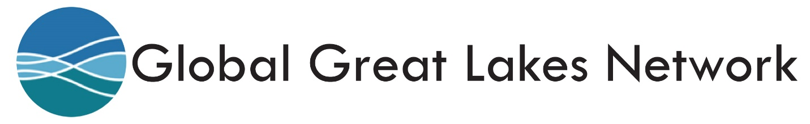
Immigrant Entrepreneurs Invited to Enter Contest with $1,000 Prize for Best Success Story

FOR IMMEDIATE RELEASE

ST. LOUIS, November 17, 2014 – Immigrant entrepreneurs and immigrant-owned small businesses in the St. Louis region are invited to enter a contest offering a $1,000 prize for the best success story describing their experience. Deadline for entries is 11:59 p.m. on November 26, 2014.

Called “A Day in the Life of an Immigrant Entrepreneur,” the contest is sponsored by the Global Great Lakes Network (www.globalgl.org), a regional initiative bringing together organizations working to tap into the economic opportunities created by immigrants, in collaboration with New America Media (www.newamericamedia.org), the country's first and largest national collaboration and advocate of 3,000 ethnic news organizations. The local lead organization for the GGLN in St. Louis is the St. Louis Mosaic Project (www.stlmosaicproject.org). Entries should be submitted to Betsy Cohen, Director, at Ecohen@worldtradecenter-stl.com.

Local entries will be judged by the Lead Organization in each of the cities in the Global Great Lakes Network. A single cash prize winner will be selected at random from among all of the regional winners. The $1,000 prize will be paid directly to the immigrant entrepreneur. The best of the regional entries will be assembled in a book celebrating the positive economic impact of foreign-born entrepreneurs.

CONTEST RULES
- Entries may be submitted by the immigrant entrepreneur or they may be written and edited by someone other than the subject of the story, including the point person in the Lead Organization in the member community.
- Entries may include articles that have been published in blogs or other media outlets, although permission should be obtained to reprint the article, if necessary.
- Final judging of the stories will be based on the subject of the story as well as the quality of the storytelling. Lead organizations may work with the entrants to revise and improve the stories, but the submitted version must have the approval of the subject of the story.

More information on the contest is available on the Global Great Lakes Network website at http://globalgl.wordpress.com/adayinthelife/.

ABOUT THE GLOBAL GREAT LAKES NETWORK
Over the past four years, initiatives to promote immigration as an economic development opportunity have produced Vibrant Pittsburgh, GlobalPittsburgh, Global Detroit, St. Louis Mosaic, Global Cleveland, Welcome Dayton, Global Michigan and Global Lansing, as well as similar economic and community development focused programs emerging in other areas.
The Global Great Lakes Network’s mission is to engage in activities that strengthen the work, maximize the impact, and sustain the efforts of individual local initiatives across the region that welcome, retain, and empower immigrant communities as valued contributors to local economic development initiatives.
Participants in the Global Great Lakes Network seek to make their regions more appealing to immigrants by improving the quality of life and economic opportunities that exist in the region for immigrants as a tool to economic growth.
Immigrant communities, when welcomed in their new home, can generate greater economic growth, job creation, and prosperity for an entire city or region. The Global Great Lakes Network comprises regional economic development initiatives working to tap into the opportunities created by immigrants.
For more information about the Global Great Lakes Network, go to www.globalgl.org or send email to globalgreatlakes@gmail.com.

* * *

