Town&Style
Student Standouts: 12.1.21
Karyn Williams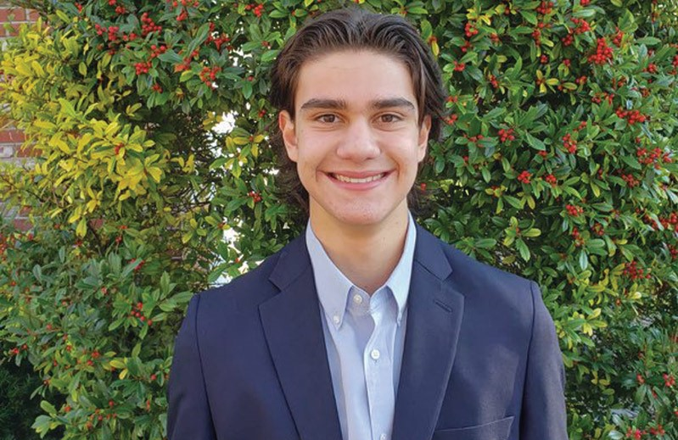
deren pellegrini of micds
In Turkish, Deren Pellegrini’s first name means “uniting, connecting,” and the MICDS junior lives up to it. Last year, he created stlcuisine.org, a website showcasing 280 ethnic restaurants in the St. Louis area. Along with supporting local businesses during the challenges of the pandemic, his goal is to help the community become more culturally connected. The site is endorsed by the St. Louis Mosaic Project and is included on the nonprofit’s list of international resources.
Where did the idea for stlcuisine.org come from?
I’m a first generation Turkish American. On a trip to Chicago, my family was dining in a really nice Turkish restaurant. I noticed that the only other people there appeared to be Turkish locals. I thought it was a shame that most people wouldn’t get to experience the food because the restaurant can’t afford to widely advertise itself. It’s the same for a lot of places in St. Louis. I wanted to find a way to help people find restaurants from any nationality so they can go enjoy the food.
Why did you pick food as a way to connect people with different cultures?
I believe that food tells a unique story about each culture and unites people within the broader community. The success of the immigrant community also is personally important to me. Inclusive prosperity is something that I really believe in. By sharing these restaurants, my goal is to elevate immigrant-owned businesses and make them more visible so they can continue to operate at no additional cost to them.
What do you hope to do next?
The website is just one of my projects related to inclusivity. I’m also co-chair of MICDS’ International Council, so I have that platform, which provides me a larger audience through the school. Right now, we’re tutoring refugee students, and I’m looking forward to other initiatives. This spring, we’ll host the International Expo, which is an event where parents and students set up booths to share different cultures.
What do you enjoy doing in your free time?
I’ve played hockey since I was five, and most of the time, you can find me at the rink. I’m the goalie for our varsity ice hockey team. I’m also a Level 3 ice hockey official and have refereed more than 100 youth hockey games. My sister and I volunteer with KEEN (Kids Enjoy Exercise Now) most weekends as well. The nonprofit lets us play sports with kids with disabilities.
How is it being both a hockey player and ref?
Refereeing has really helped me build my character, and I’ve had some interesting new experiences like people arguing with my calls or parents coming onto the ice. I’m sure it’s the same for a lot of refs. As a player, I like how many different aspects there are to hockey. I think the mentality I’ve developed through the game has helped me with a lot of things in life in general.
Categories: Town Talk Features

