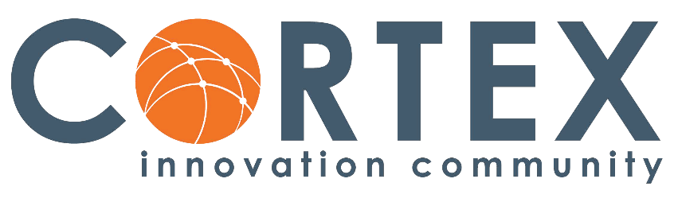
As a St. Louis Mosaic Project Ambassador Company, Cortex is or will take the following actions:
- Ensure that their website reflects diversity and is welcoming and accessible to foreign-born or ethnic applicants
- Join the Hispanic and Asian Chambers of Commerce and sponsor a reception
- Provide diversity and inclusion training for employees
- Celebrate multicultural events/holidays
- Have ERG groups for employees who share gender, ethnicity, religious affiliation, lifestyle, or interest
- Hold an event to promote Mosaic programs to the broader community
- Serve as a communication partner to share information about our resources

